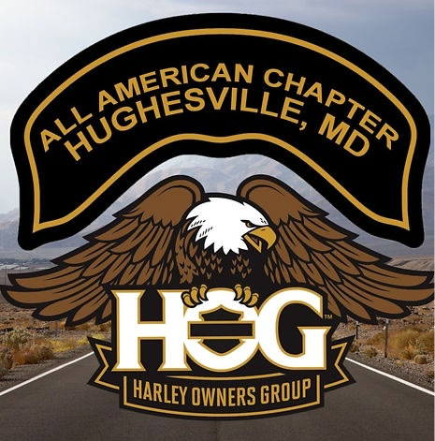

“How to become a Road Captain”

H.O.G. Chapter Handbook Addendum for All American Harley Davidson H.O.G. Chapter #3887

**What is a Road Captain?**

Per the HOG Chapter Charter Road Captains assist in planning and executing rides. They also provide the assistance in riding Wing, and Tail Gunner (also called Sweep in some chapters) during rides to help ensure the group arrives safely. For All American H.O.G., a Road Captain is a chapter member who provides the desire, willingness, dedication, and ability; to plan, organize, and lead a ride with chapter members and guests on rides to various locations, events, and destinations.

**What is the Definition of a Ride?**

A qualified ride for All American Harley Davidson H.O.G. ride requires a minimum of at least two members.

**What is the Definition of a Successful Ride?**

A successful ride is defined as a ride, where a group (minimum two) depart a start location and end at a desired location safely having fun and enjoying the ride.

**How to become a Road Captain**

First step to becoming an All-American Harley Davidson Chapter Road Captain is contact anyone of the current Road Captains or Chapter Officers with your interest.

These members will be glad to talk with you and put you in contact with the Head Road Captain (HRC) to begin your journey. There will be things you can do in the meantime to help get you started.

* First, go to the Chapter Website and locate the H.O.G. Charter and Chapter Handbook. These contain much of the information disseminated by H.O.G. for leading rides within a H.O.G. organization.
* Next, sections to become familiar with are the H.O.G. Forms within the Charter and Handbook.

To see these forms and others any member can log into the Road Captain Resources area of the Chapter website in the Road Captain Resource Page.

* Last, once you are in contact with our HRC, they will get with you to go over the AAHD RC Discussion guide and continue your journey in becoming an AAHD Road Captain. Once you meet with the HRC and received your RC Checklist you can then begin working with a mentor and/or other chapter RCs to get you checklist signed off. First you will sign off your required reading and then begin working to get your ride signatures completed.